**DJANGO**

**1. Install of Python**

https://www.python.org/downloads/

**2. Installation of PyCharm**

https://www.jetbrains.com/pycharm/download/#section=windows

# IDE: PyCharm

# Help (Menu) -> **About**

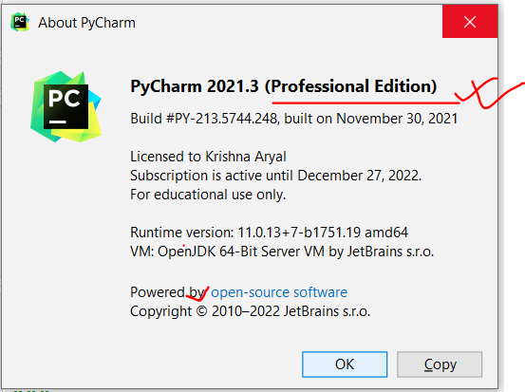

**3. Creating new Project (Django Project -> Website)**

* **File** (Menu) > **New Project**

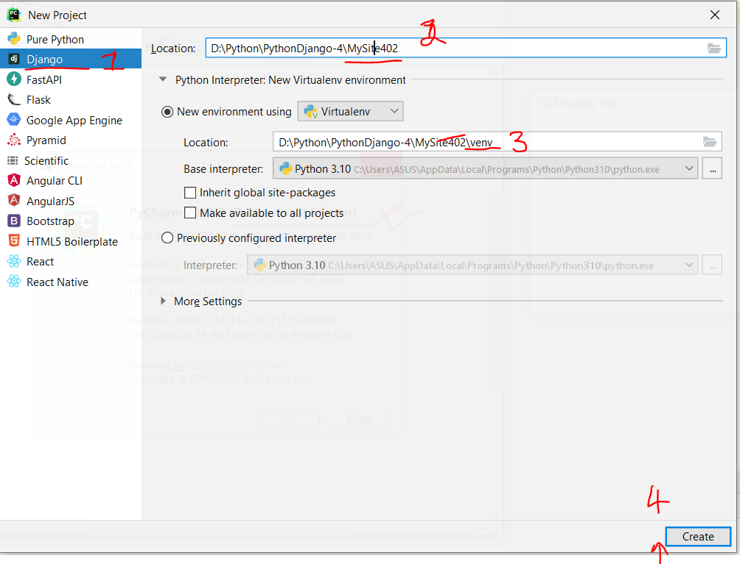

* Click on **Create** button

**4. Explore Django Project**

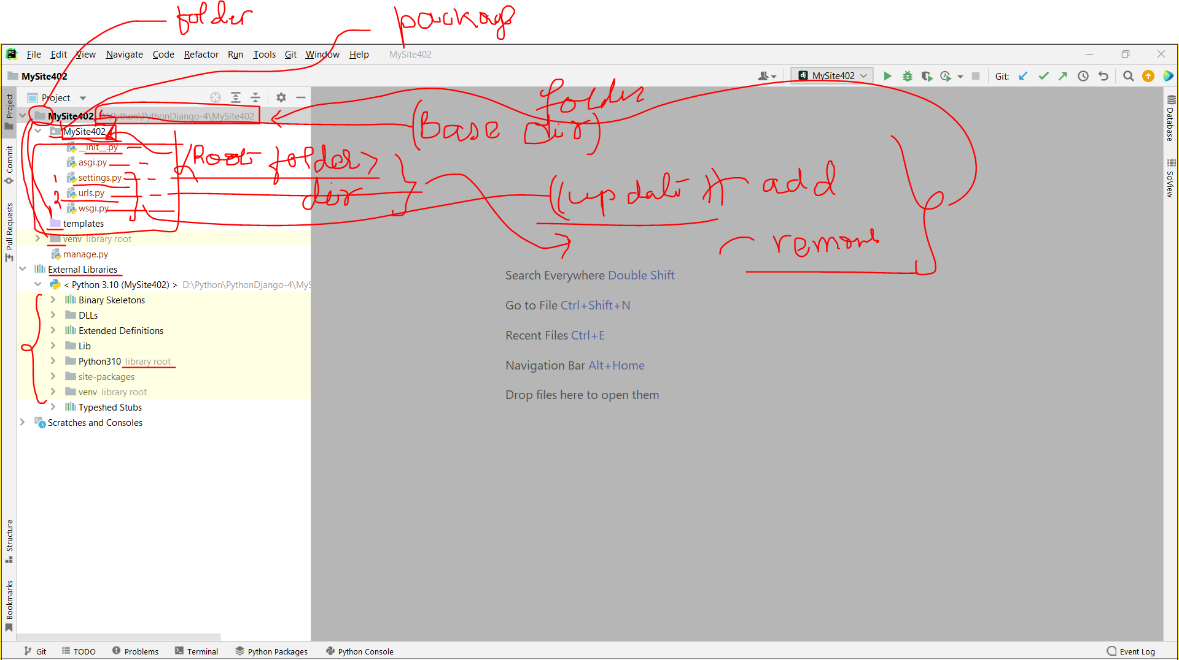

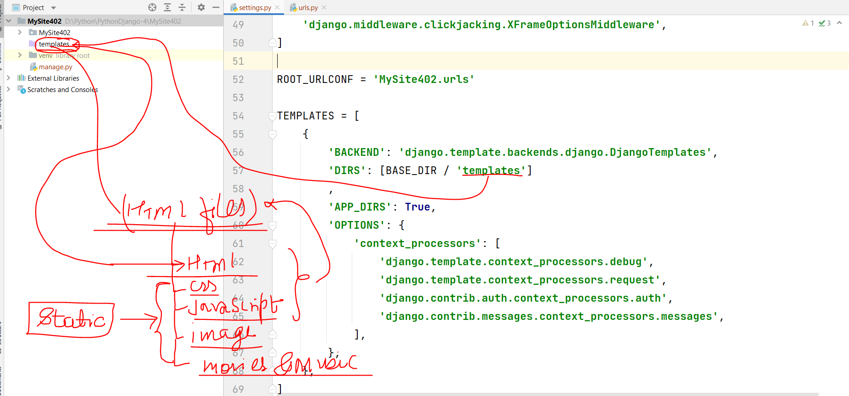

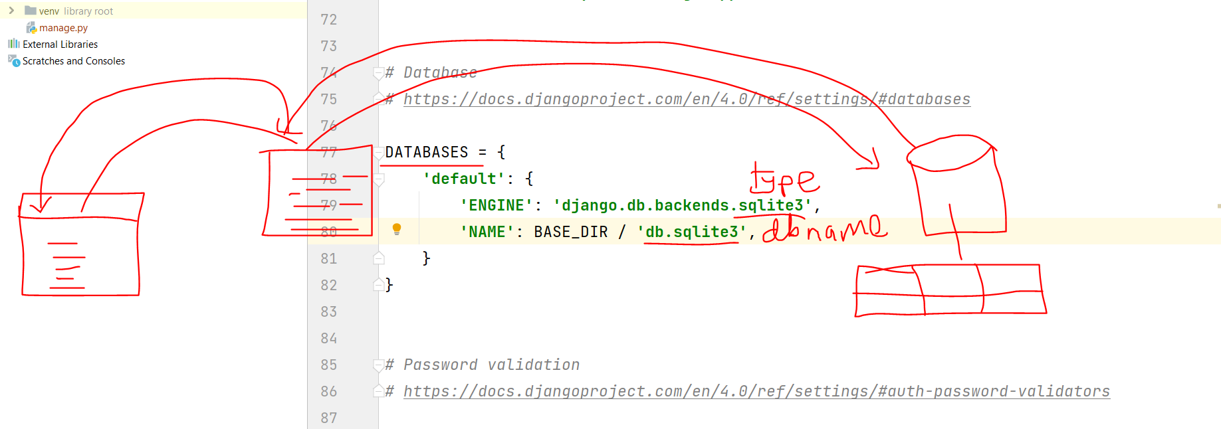

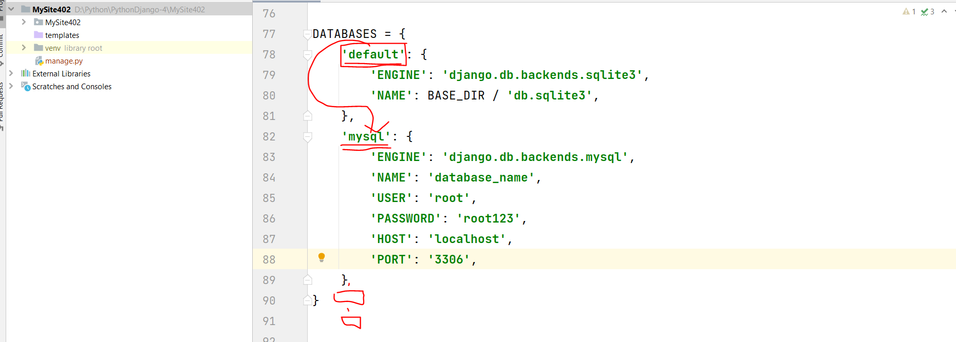

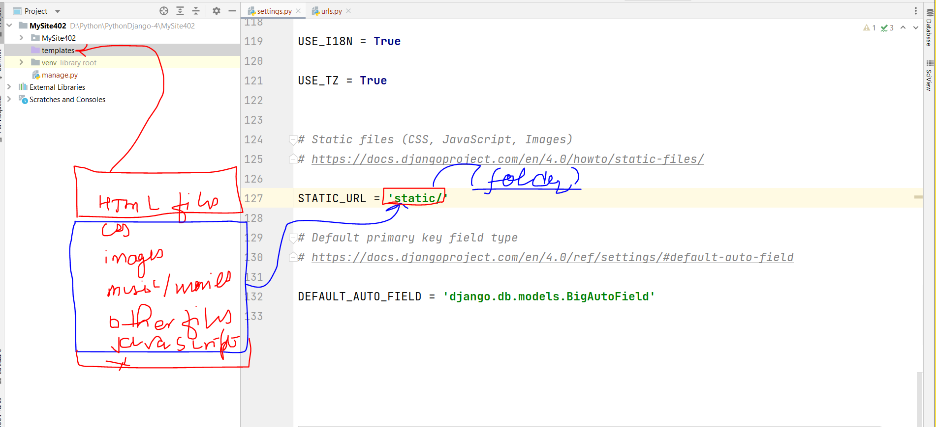

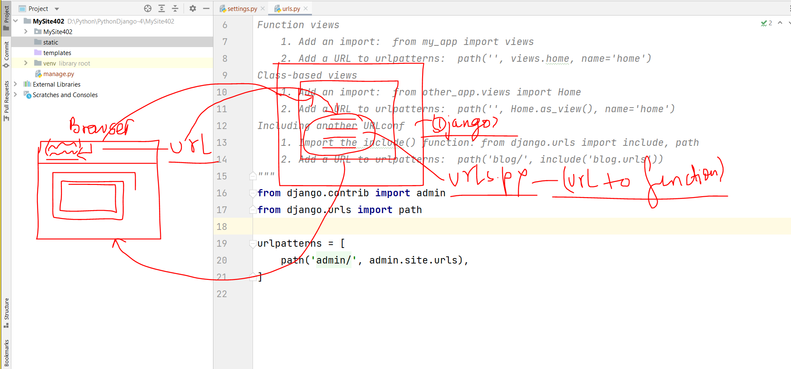

**settings.py**

**Testing/development**

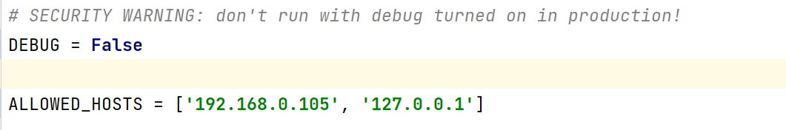

**Production/live site**

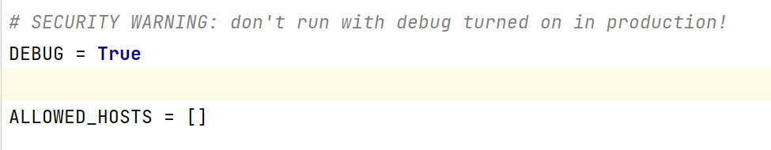

**Terminal > ipconfig/all**

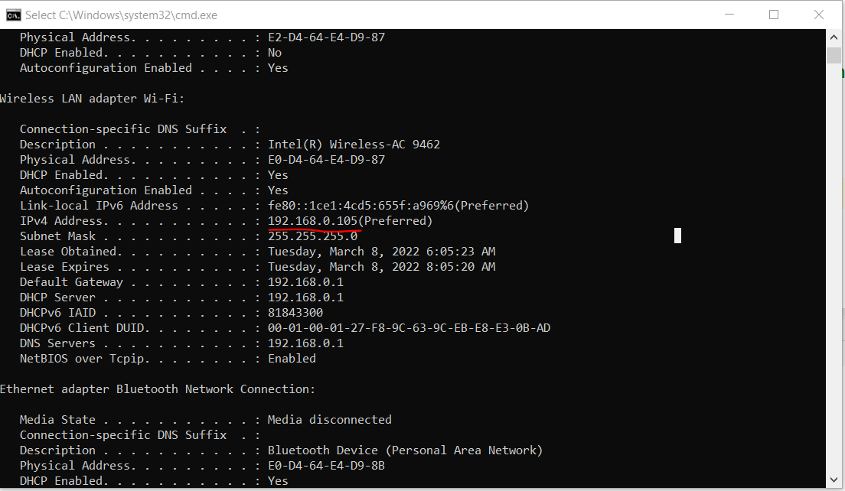

**5. Startring website (Up)**

**a.** Terminal **->** python manage.py **runserver**

**or**

b. Tools (Menu) -> **Run manage.py Task (Terminal of manage.py)**

**runserver**

**6. Website stop (down)**

Ctrl + Z or Ctrl + C

**7. Browse the website**

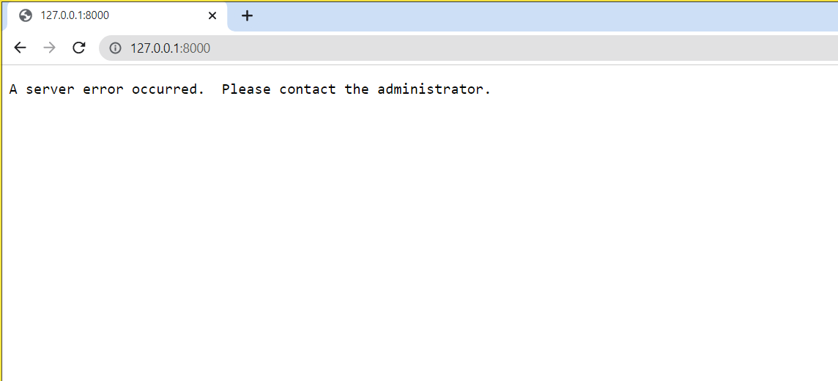

**8. Port in Server Start**

**General Terminal Command**

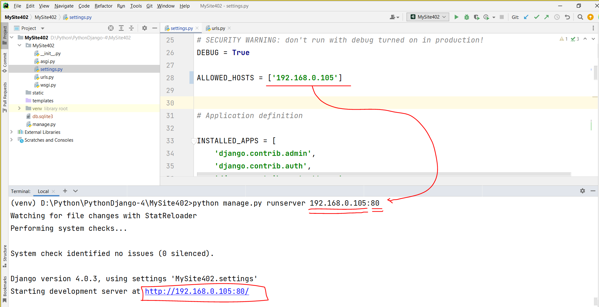

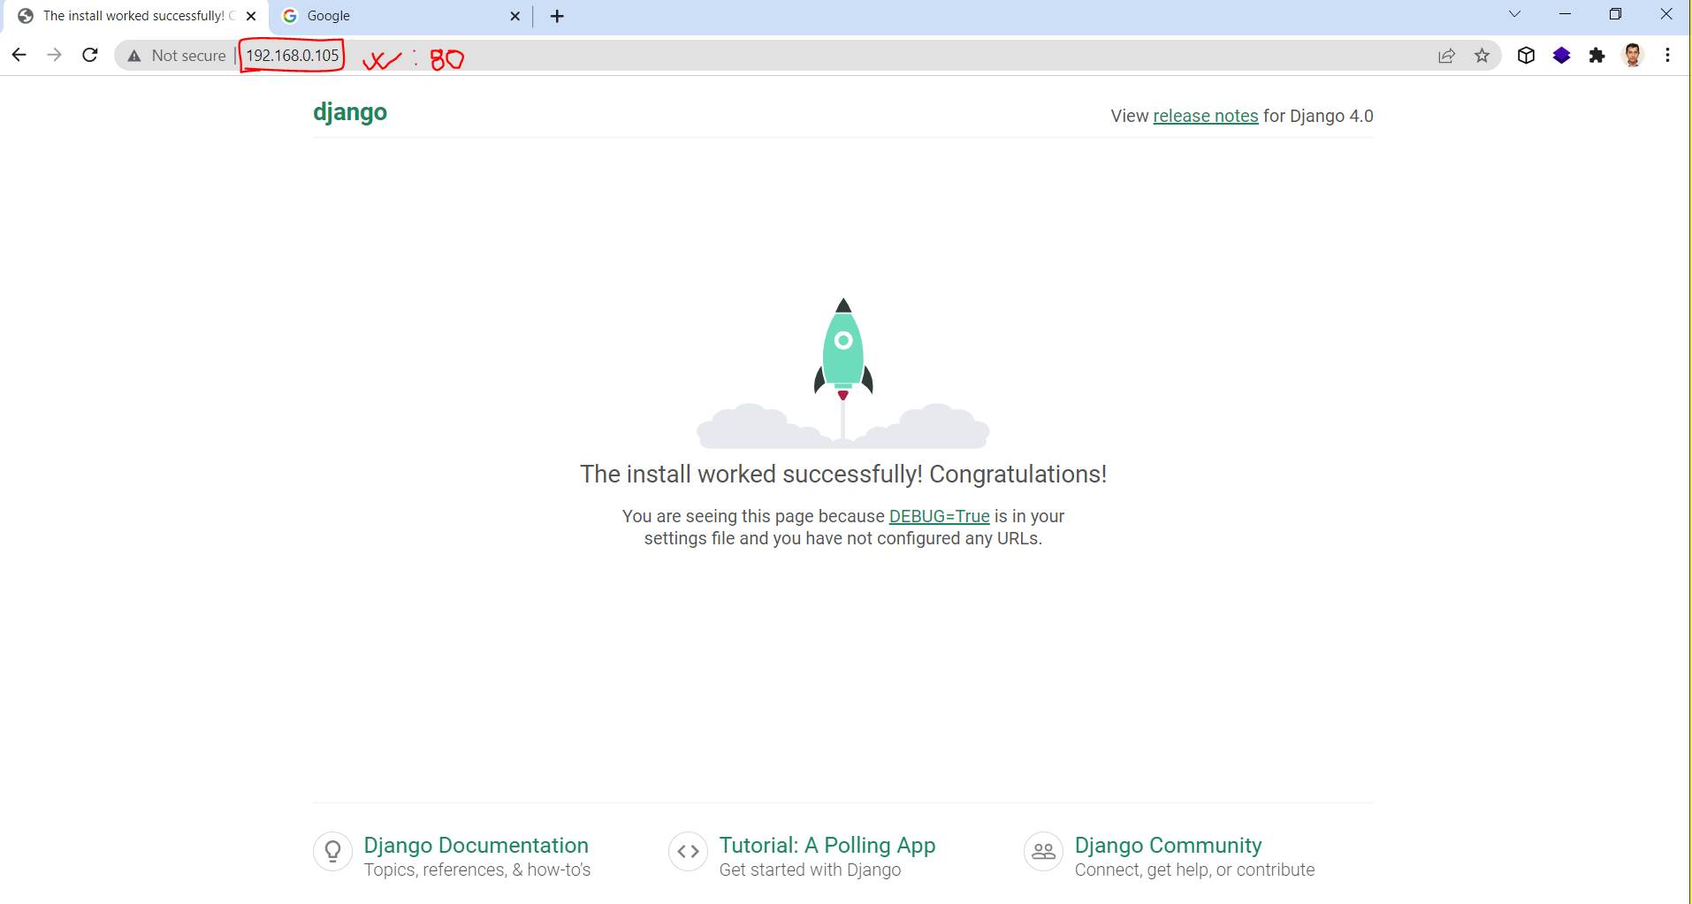

**Manage.py terminal**

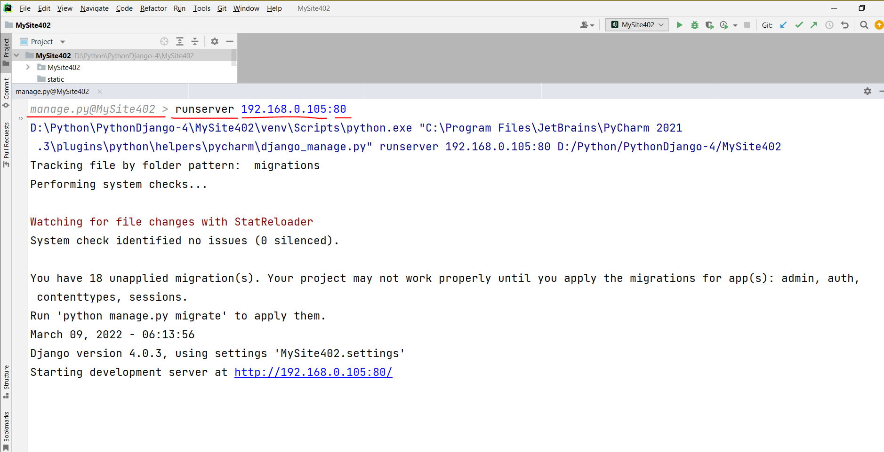

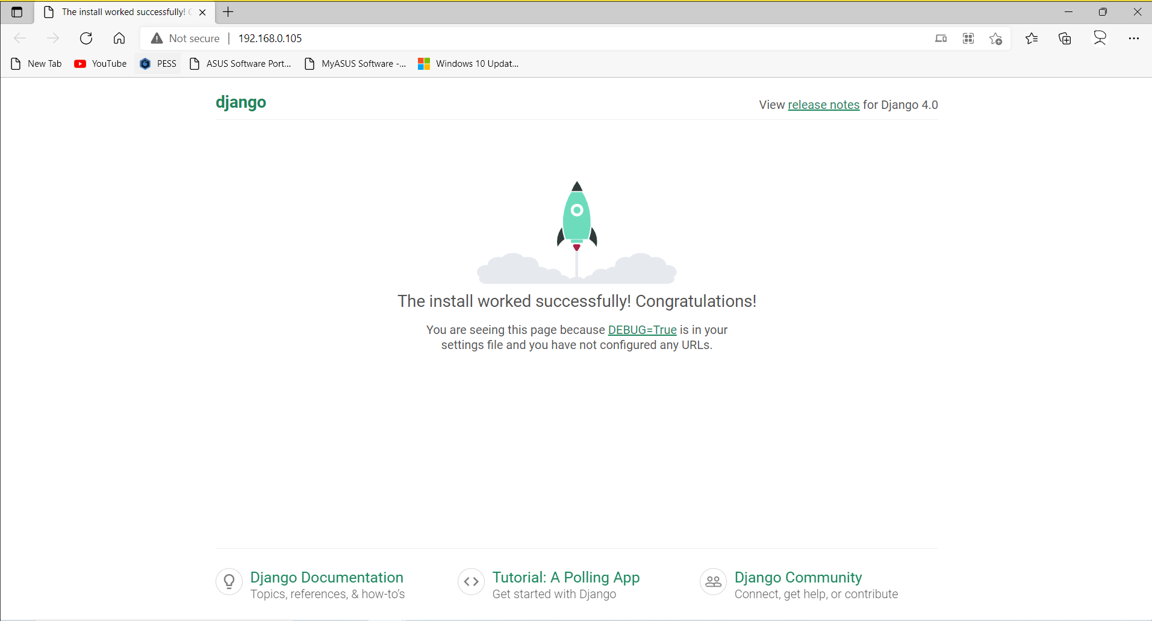

**Task-1**

* Display “Hello world of Django!” in browser.

**Solution-1 (RootDir)**

* Create **views.py** file
  + Create view **function** to return “Hello world of Django!”

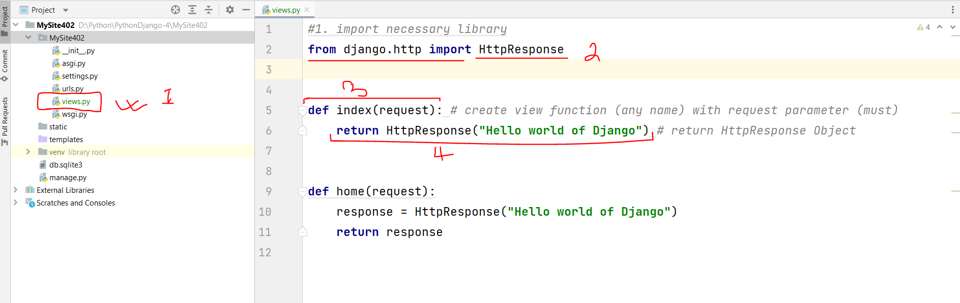

* Create **new url pattern** (update root’s **urls.py** file)

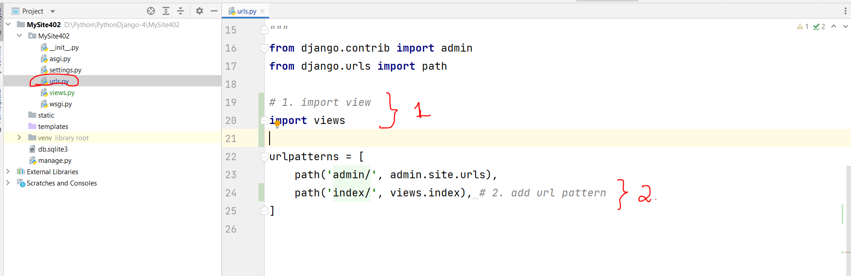

* Run server and browse

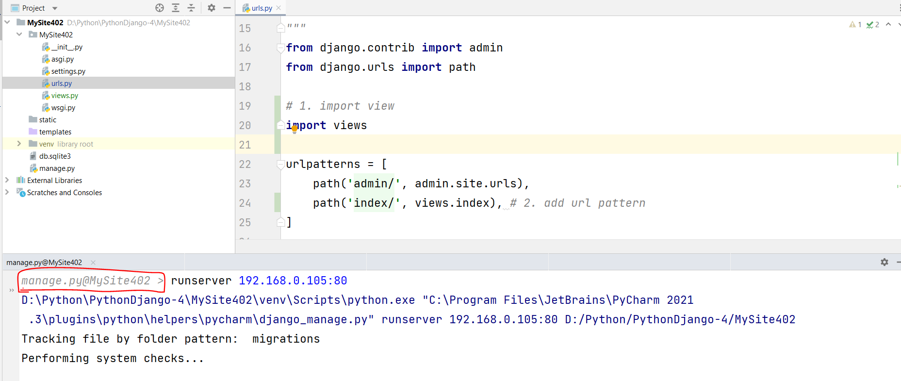

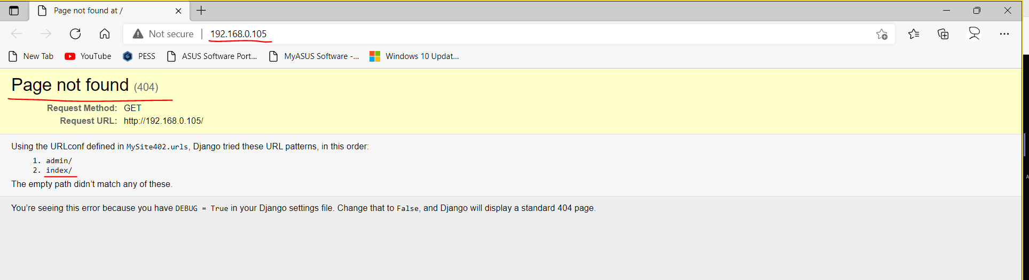

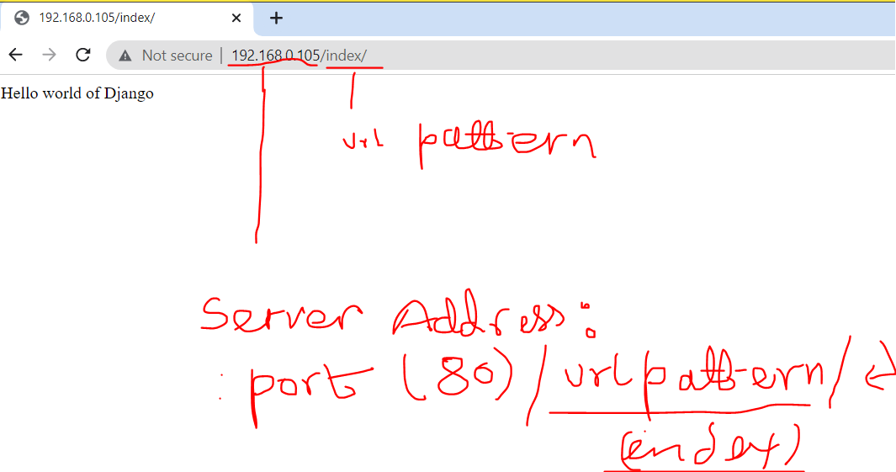

**Task-2:** Create the following views functions and urls pattern to call respective view functions.

* defualt (Home page)
* successgallery
* testimonials
* onlineadmission
* paymentoption
* offers
* career
* contactus
* blog

**Solution-2 (App)**

* Creating new app
  + Terminal -> python manage.py startapp **app1_1**

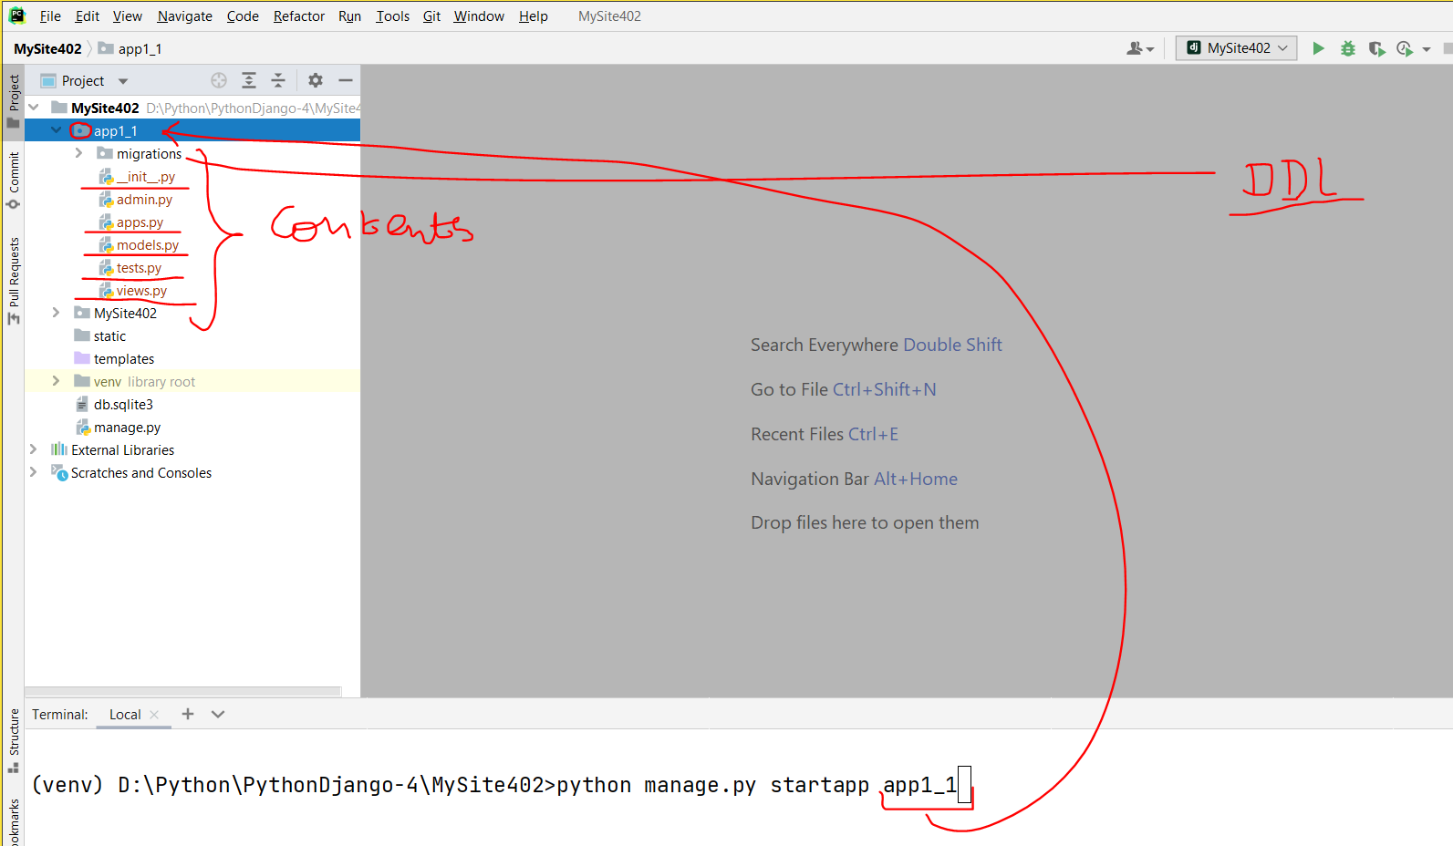

* Register app in rootdir/settings.py -> INSTALLED_APPS -> add app_name in list ‘**app1_1**’

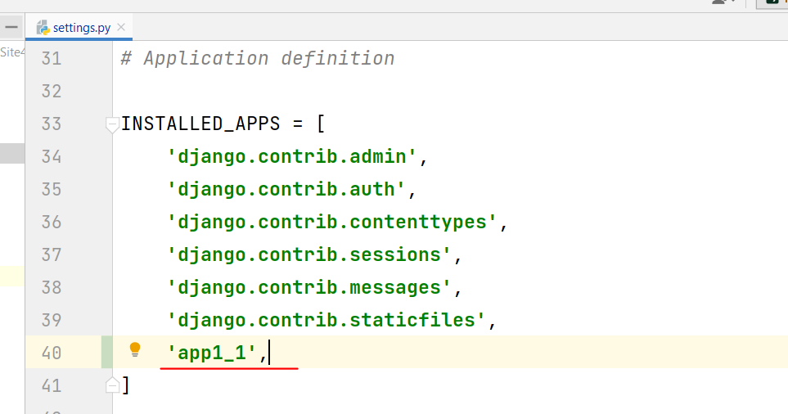

* Create views functions in app (app1_1\**views.py**)

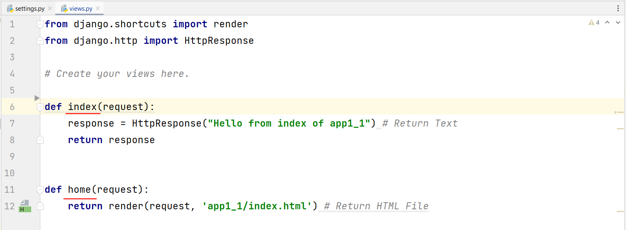

* Create new urls.py file in (app1_1\**urls.py**)

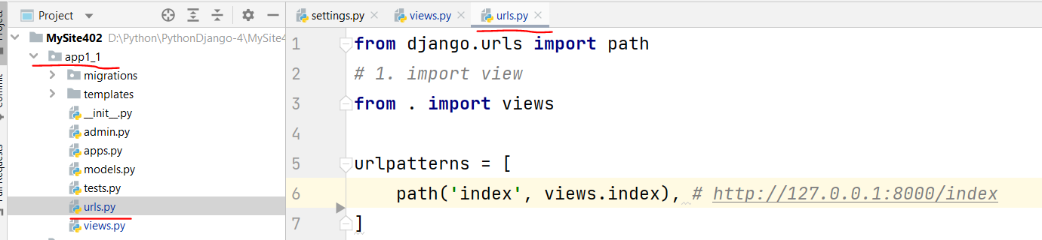

* Update in root urls.py (MySite402\**urls.py**)

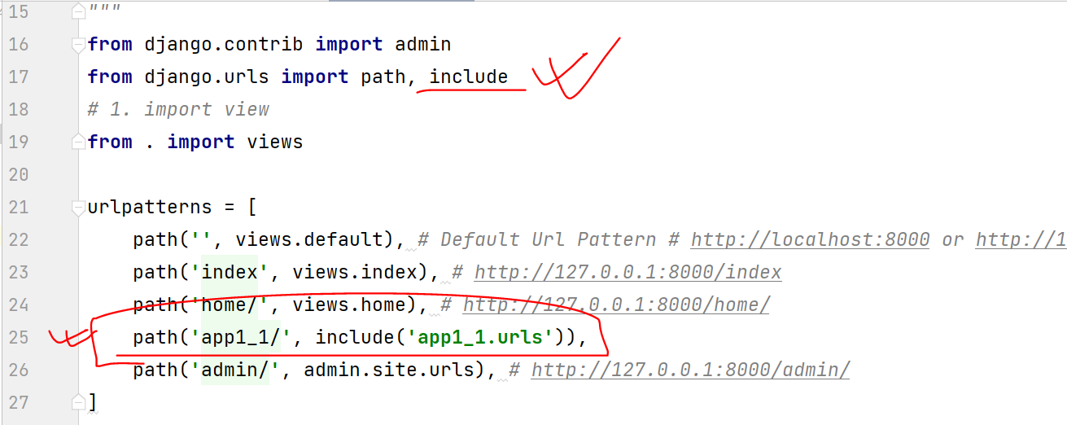

* Browse Site

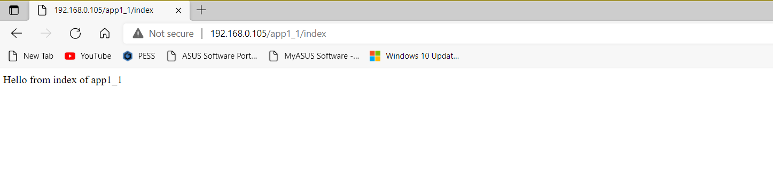

**Task-2:** Create multiple apps and integrate in site.

* defualt (Home page)
* successgallery
* testimonials
* onlineadmission
* paymentoption
* offers
* career
* contactus
* blog

**9. Loading Static Contents (css, image, javascript).**

* Create new app (**app1_2**)

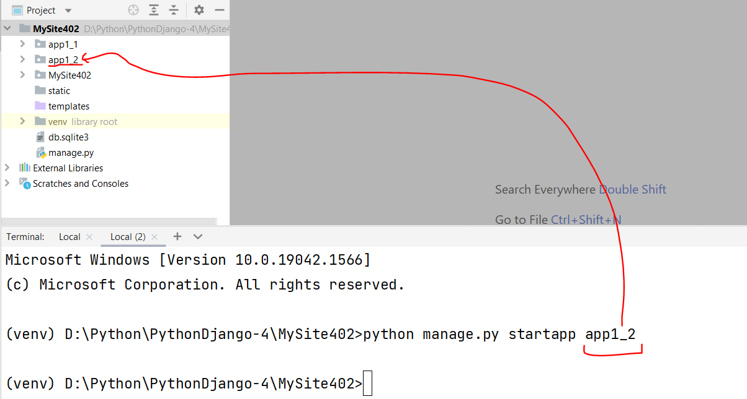

* Register newly created app (root\settings.py\**INSTALLED_APPS**)

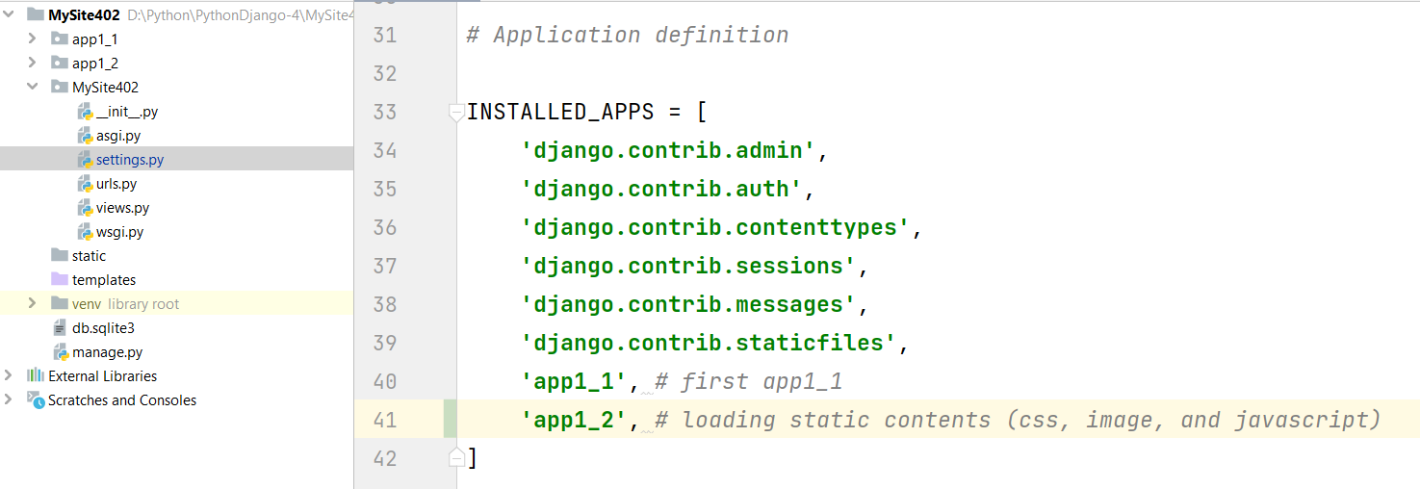

* Upate in root\settings.py by adding **STATIC_ROOT**
  + Create **static** folder in base dir

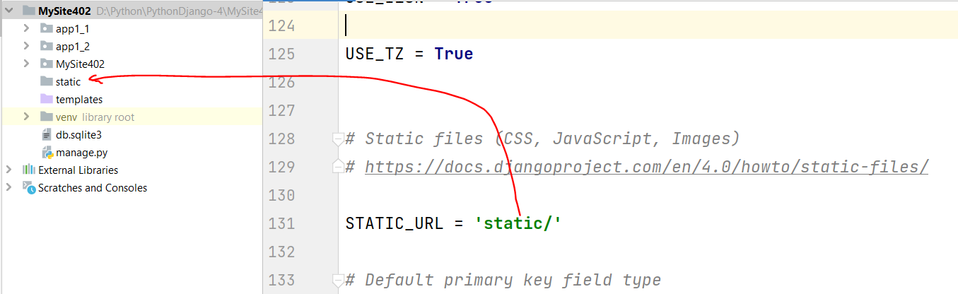

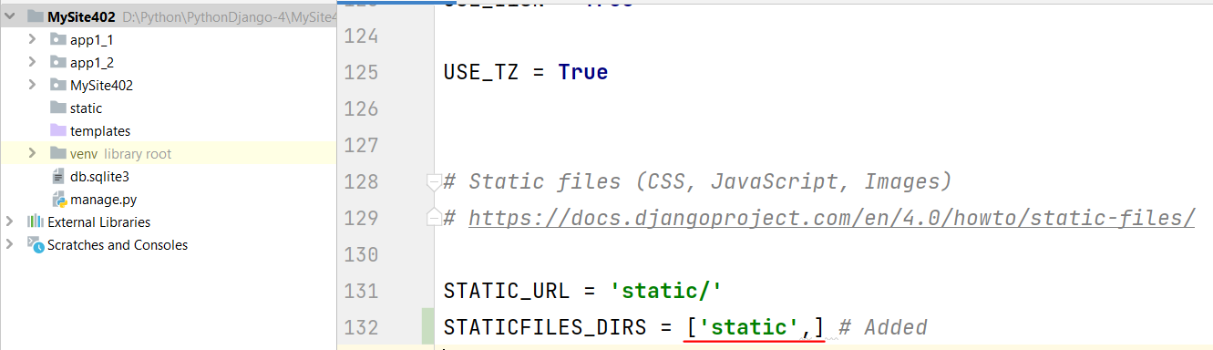

* Create static contents (**css, image, and JavaScript**)
  + BaseDir\static\app1_2\**css** – folder
  + BaseDir\static\app1_2\**images** – folder
  + BaseDir\static\app1_2\**js** – folder
* Create template (**html file**)
  + app1_2\templates\app1_2\**index.html**
* Import/Link **static contents** in template (index.html)

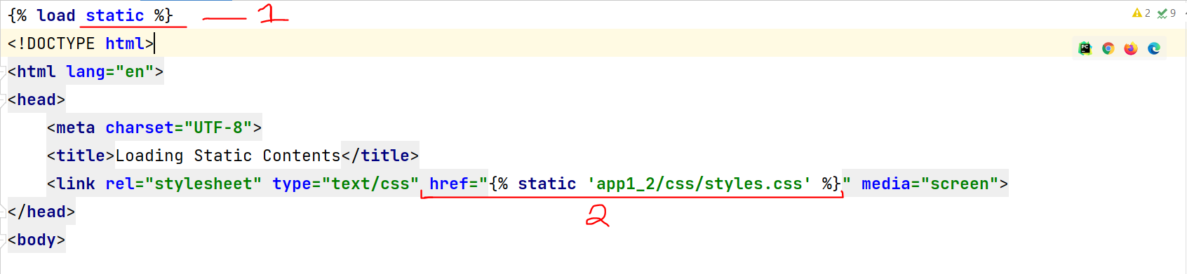

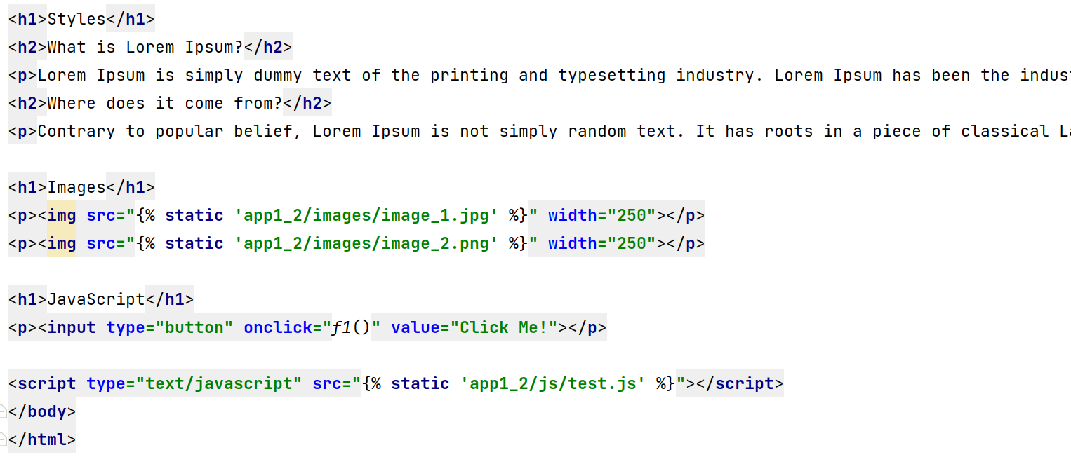

* Create **view** functions in app1_2

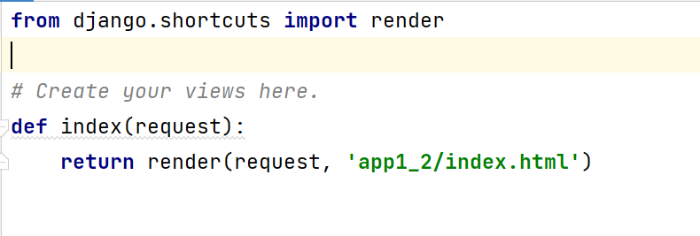

* Create **urls.py** in app1_2

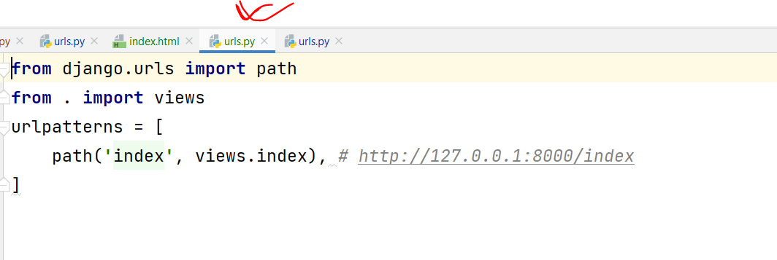

* Update **root\urls.py**

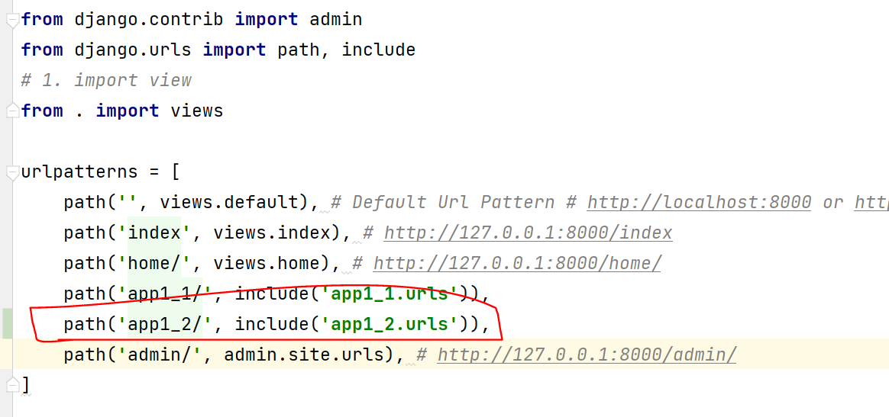

* **Browse site**

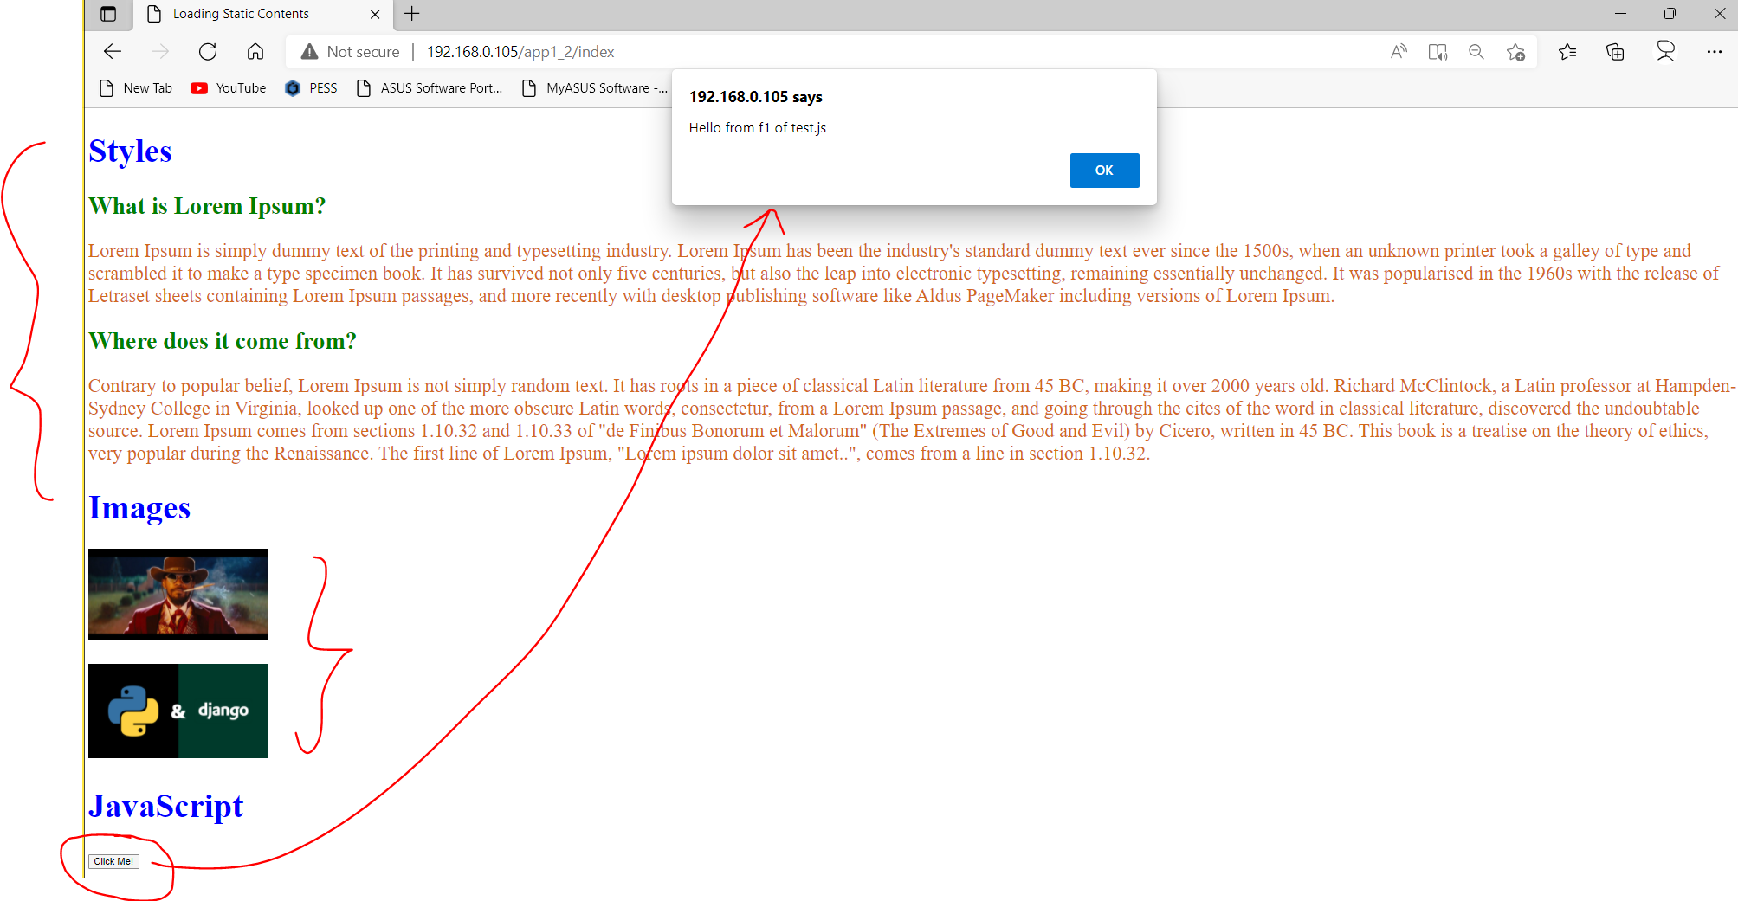

**Note:**

* **HTML, CSS, JavaScript**
* **Bootstrap**
* **Node**, and **Angular**/View/React JS

**Task-3 (Project):** Create multiple apps and integrate in site with static resources (**css, images, javascript files**).

* home (default)
* successgallery
* testimonials
* onlineadmission
* paymentoption
* offers
* career
* contactus
* blog

**home (default)**

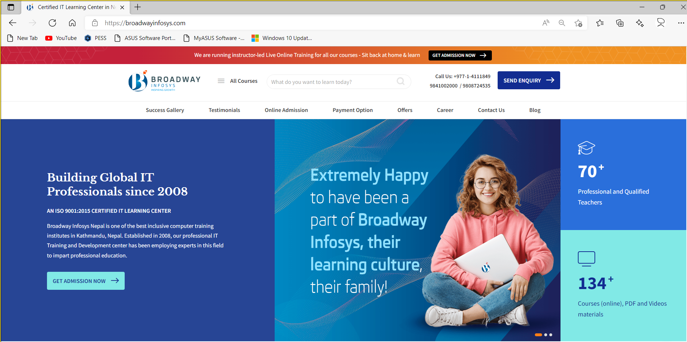

**successgallery**

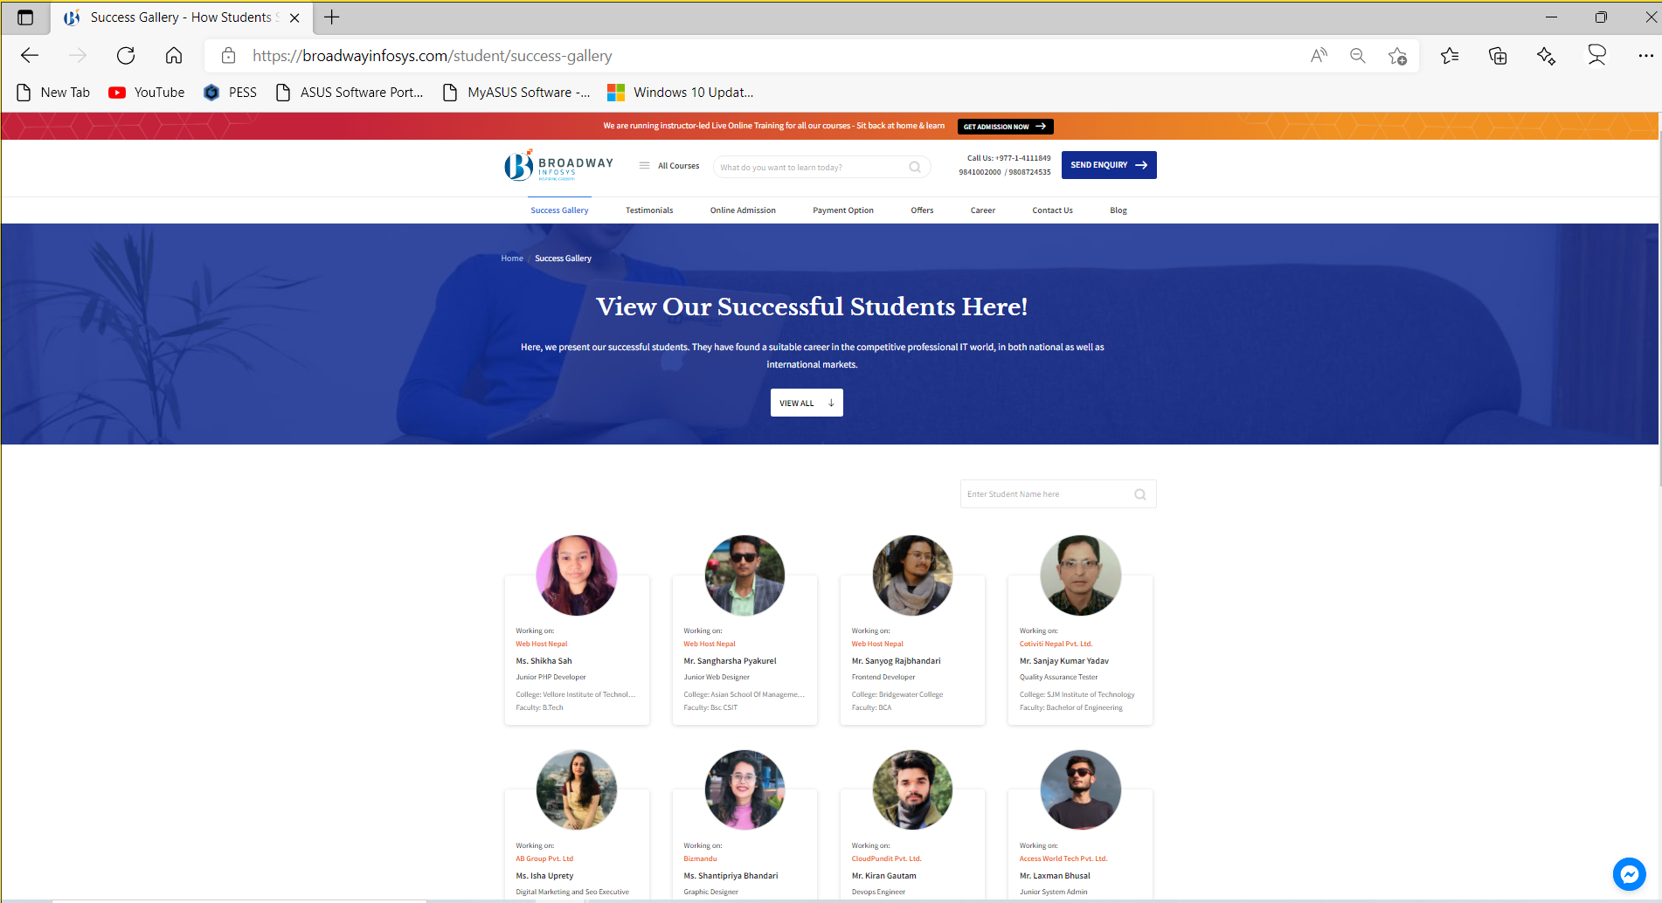

**testimonials**

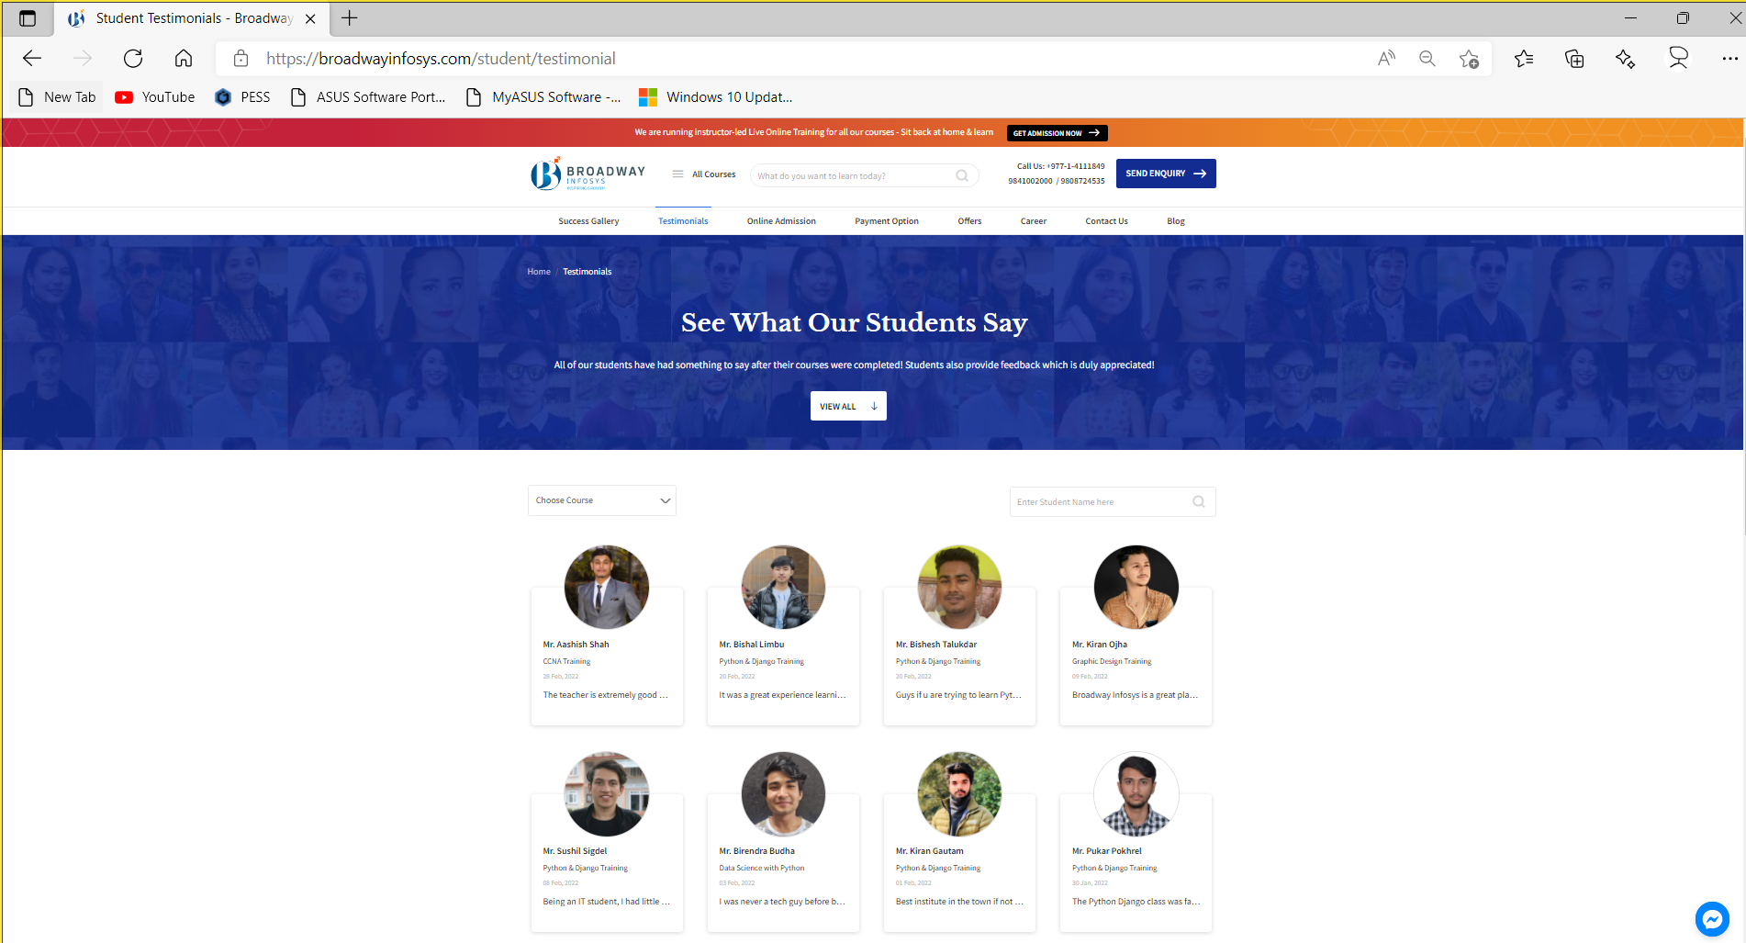

**onlineadmission**

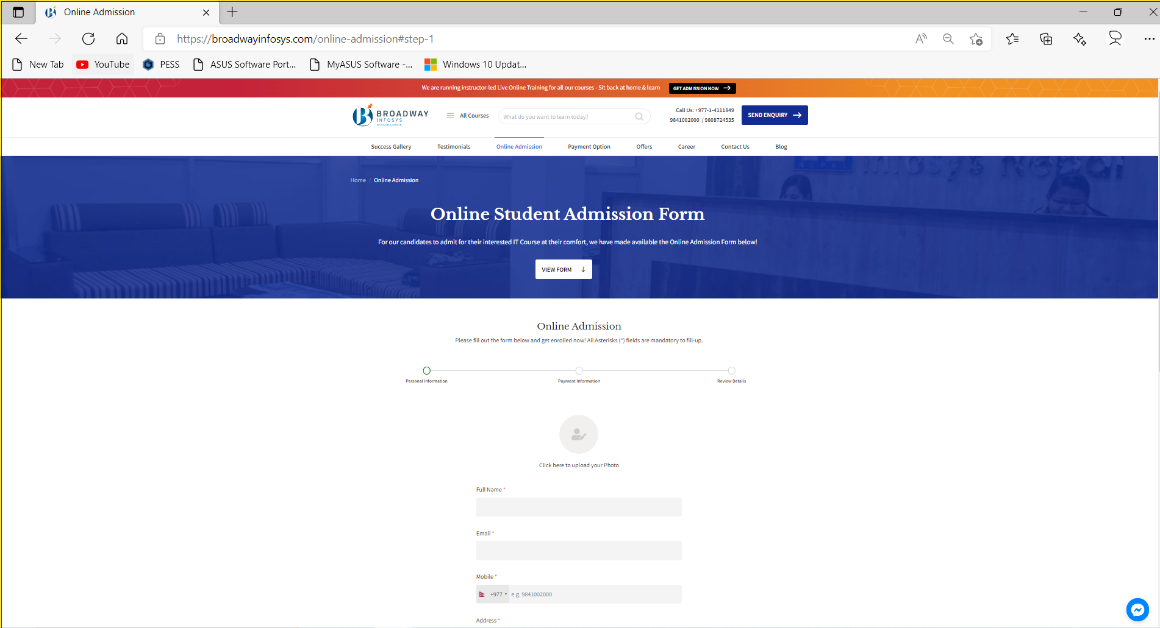

**paymentoption**

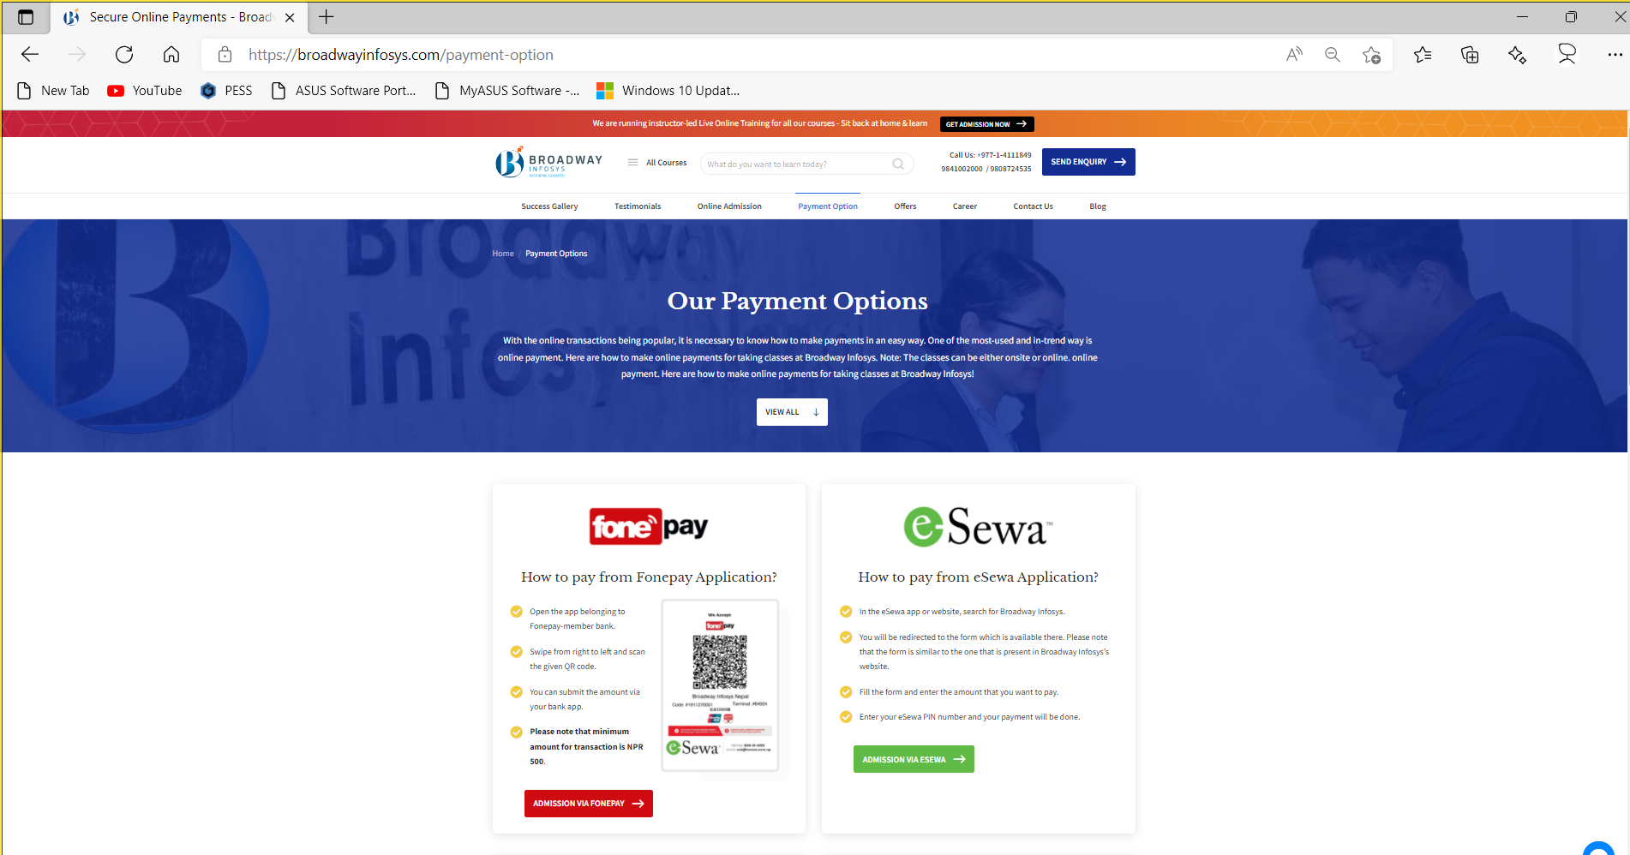

**offers**

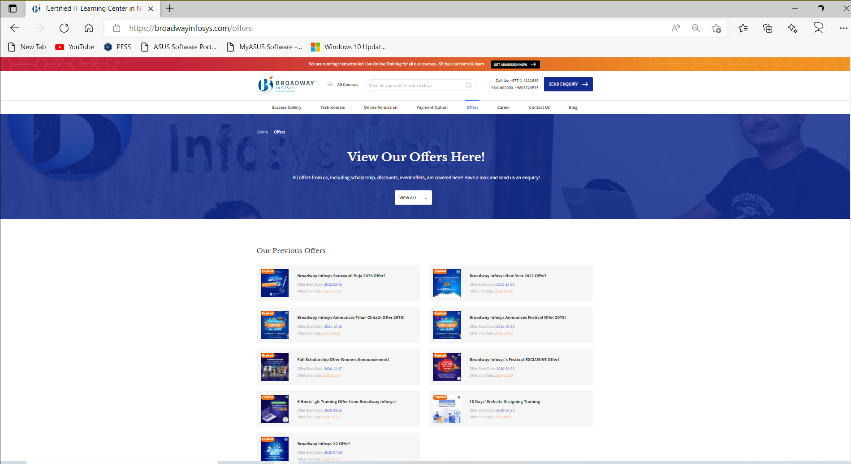

**career**

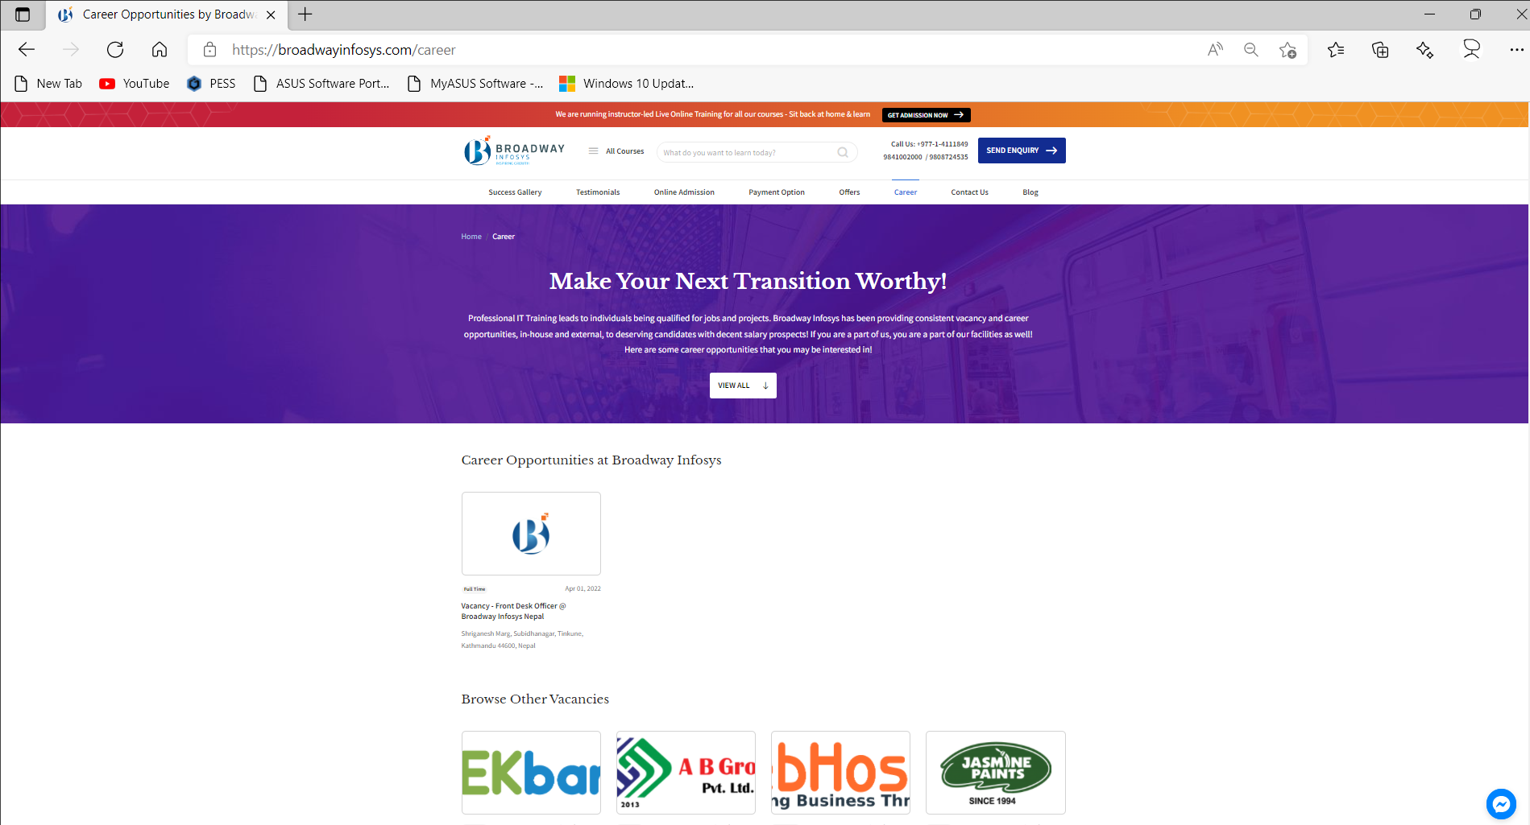

**contactus**

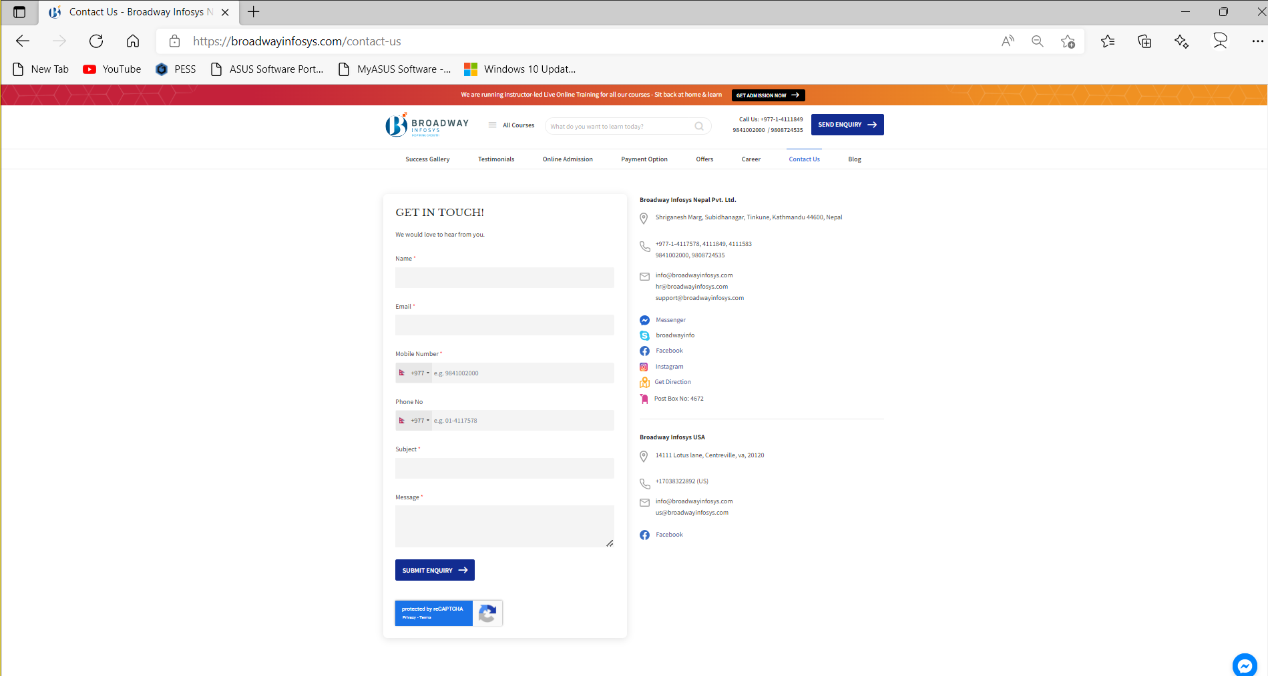

**blog**

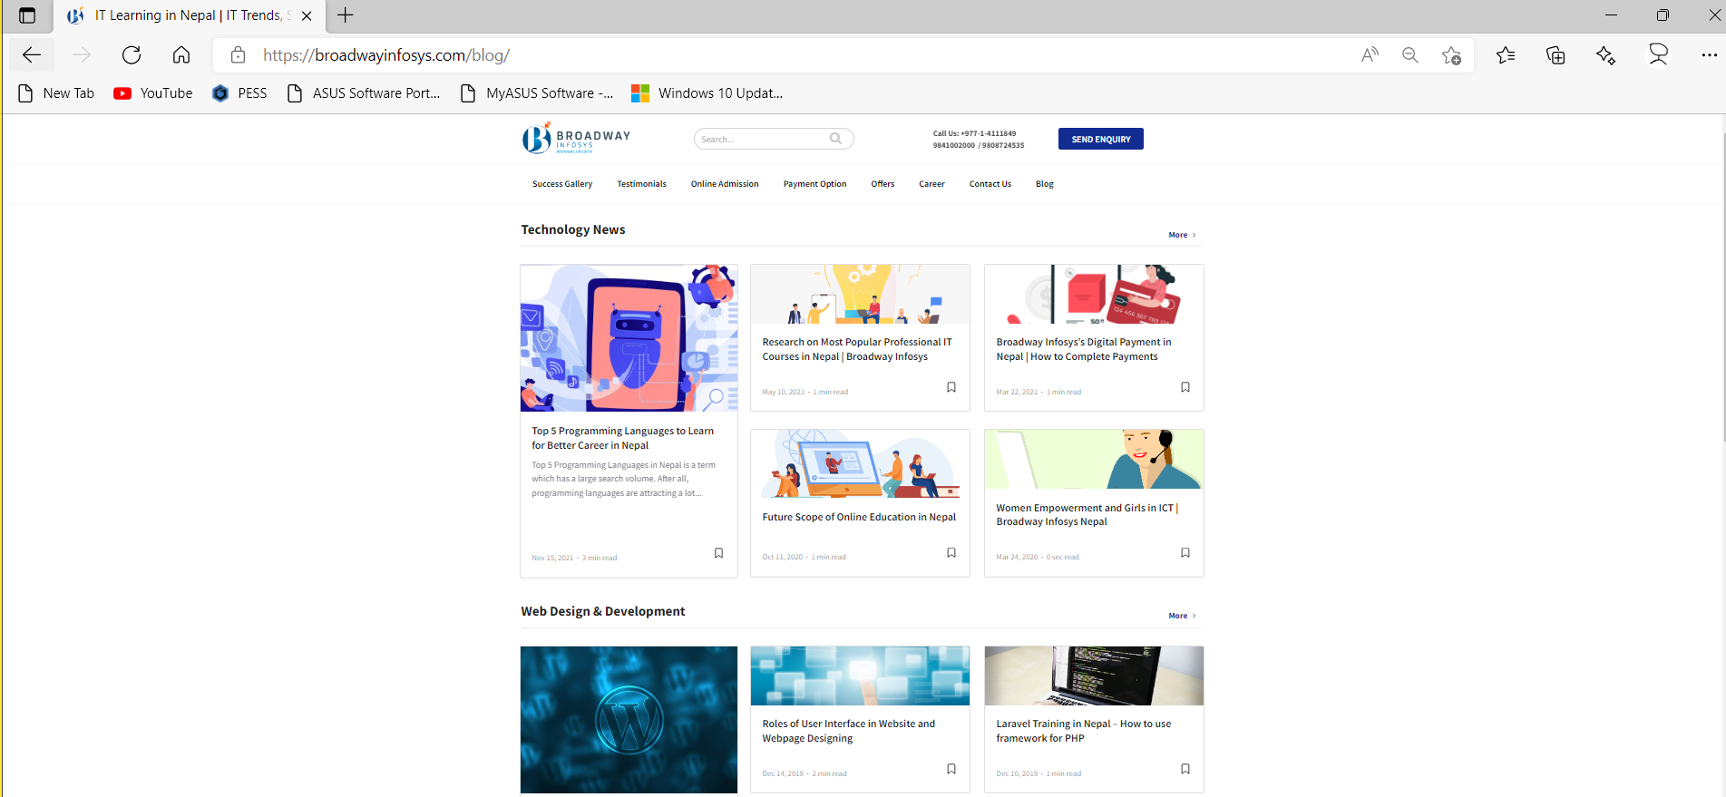

**10. Bootstrap integration**

* Download/Documentation resources
  + https://getbootstrap.com/
* Integrate Bootstrap-1 – **Online** (CDN)
  + Create new app (**app1_3**)
  + Register newly create app in **setting.py**
  + Create template file (app1_3\templates\app1_3\**index.html**)
  + From the documenation section of bootstrap library copy the template of starter and pate on **index.html**
    - https://getbootstrap.com/docs/5.1/getting-started/introduction/
  + Create view function in **views.py**
  + Create urls.py in **app1_3**
  + Update root\**urls.py** file (add app1_3\**urls.py**)
  + Browse the site
* Integrate Bootstrap-2 – **Offline**
  + Donwload bootstrap library (Compiled CSS and JS)
    - https://getbootstrap.com/docs/5.1/getting-started/download/
  + Create new app (**app1_4**)
  + Create static folder (app1_4\static\**app1_4**)
  + Place css and js folder in app1_4\static\**app1_4**
  + Create html template (app1_4\templates\app1_4\**index.html**)
  + Load static contents in **index.html** (**css, and js**)
  + Create app1_4\**urls.py**
  + Create index function in app1_4\**views.py**
  + Update root\urls.py file (add app1_4\**urls.py**)
  + Browse the site

**Task-4:**

* Create new app (app1_4) test **layout**, **content**, **forms**, **components** of bootstrap (integrate and cutomize as per requirements)

**11. Bootstrap one page site integration**

* https://bootstrapmade.com/bootstrap-one-page-templates/

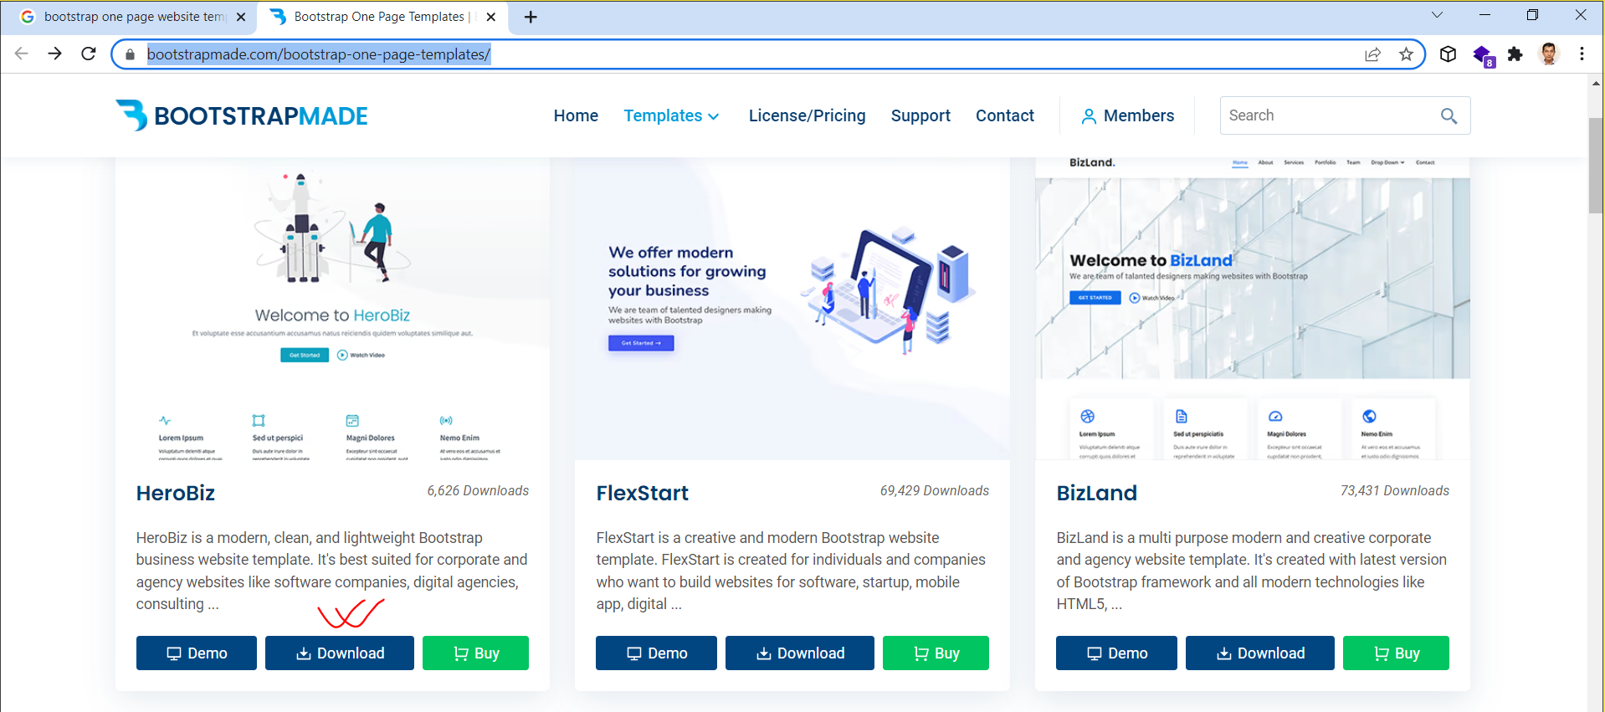

* Extract and run **index.html**

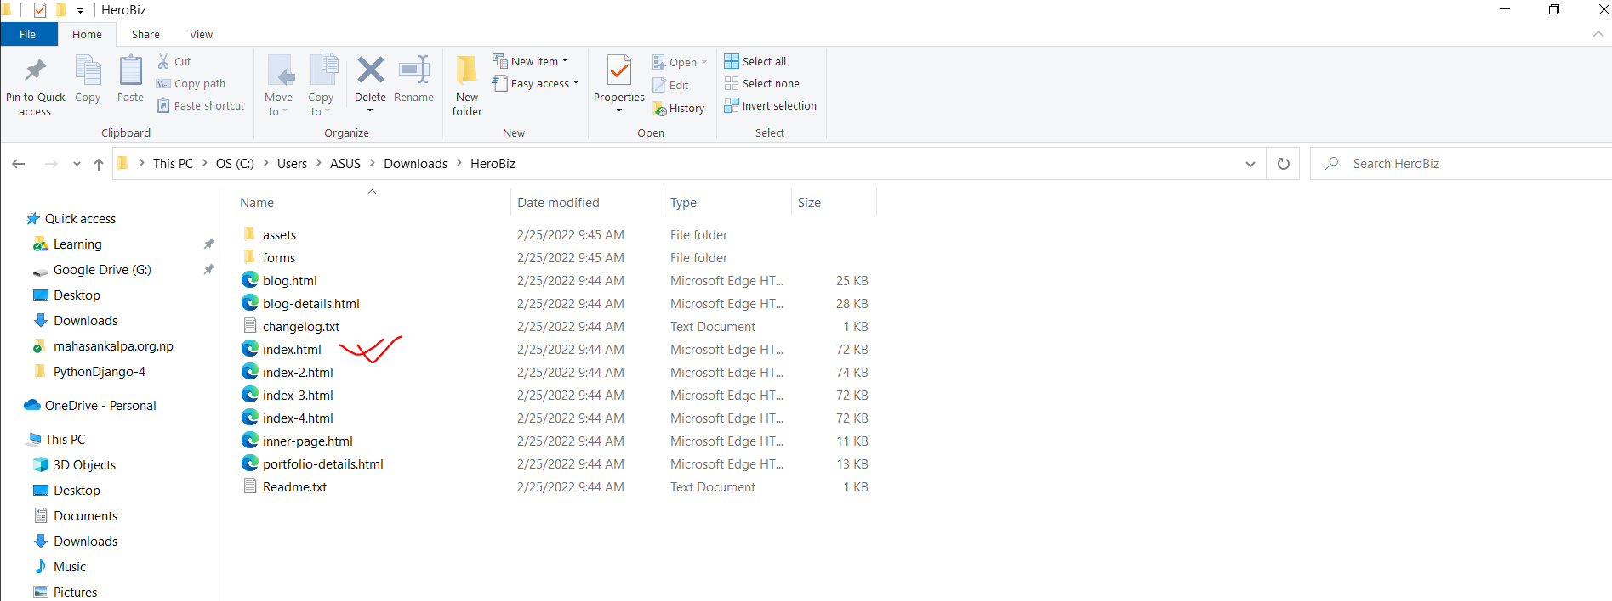

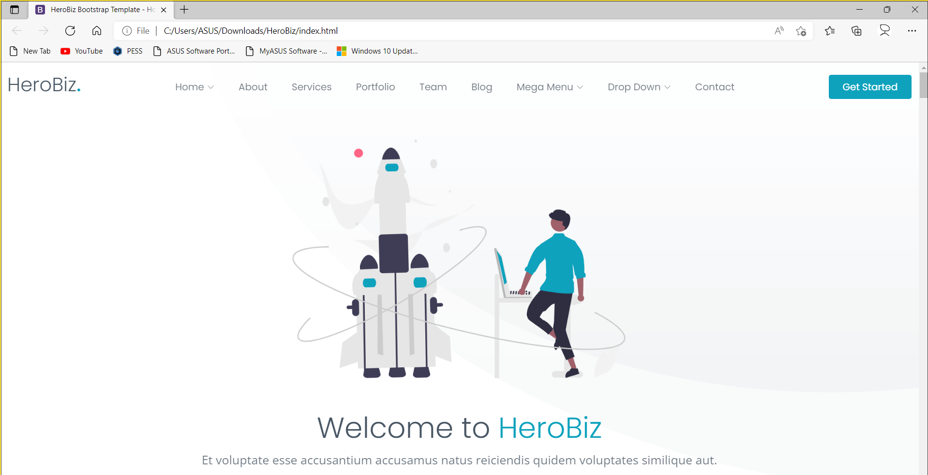

* Create new app **app1_6**
* Register app in **settings.py**
* Create **templates\app1_6** folder in app1_6 app
* Place **index.html** file in app1_6 of template folder
* Create view function to render index.html (views.py)
* Create **urlpattern** in **urls.py (‘index’)**
* Update in root\**urls.py**
* Browse the site
* Create **static** folder in app1_6
* Paste **assets** folder in static folder
* Update **index.html** file with static contents
* Browse the site

**12. Sending values (data) from client to server.**

**MVT (Model, View, Template)**

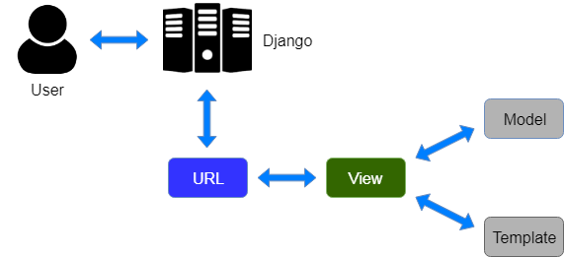

* Create new app (**app1_7**)
* Register newly created app in **setting.py**
* Create **urlpattern** and **view function (app1_7)**
* Update **root\urls.py (add app1_7\urls.py)**
* Browse the app

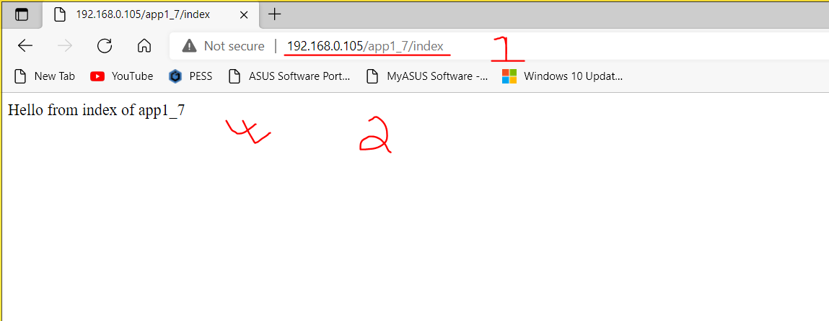

* **Sending value from url to views**

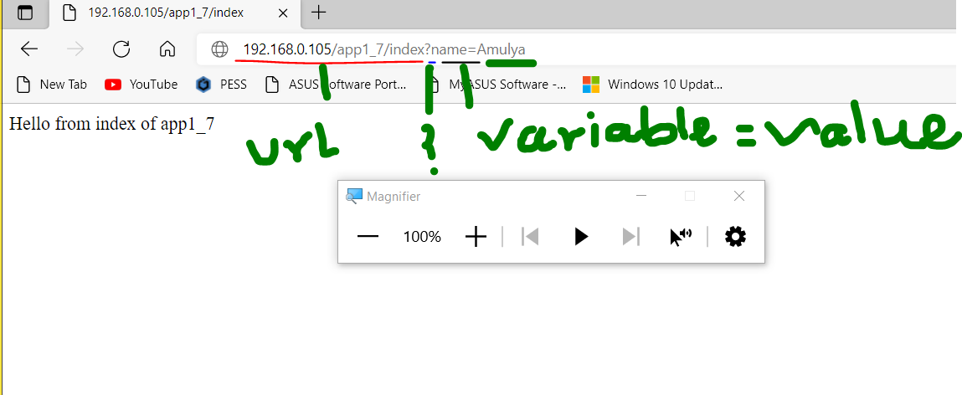

* **Receive value in views**

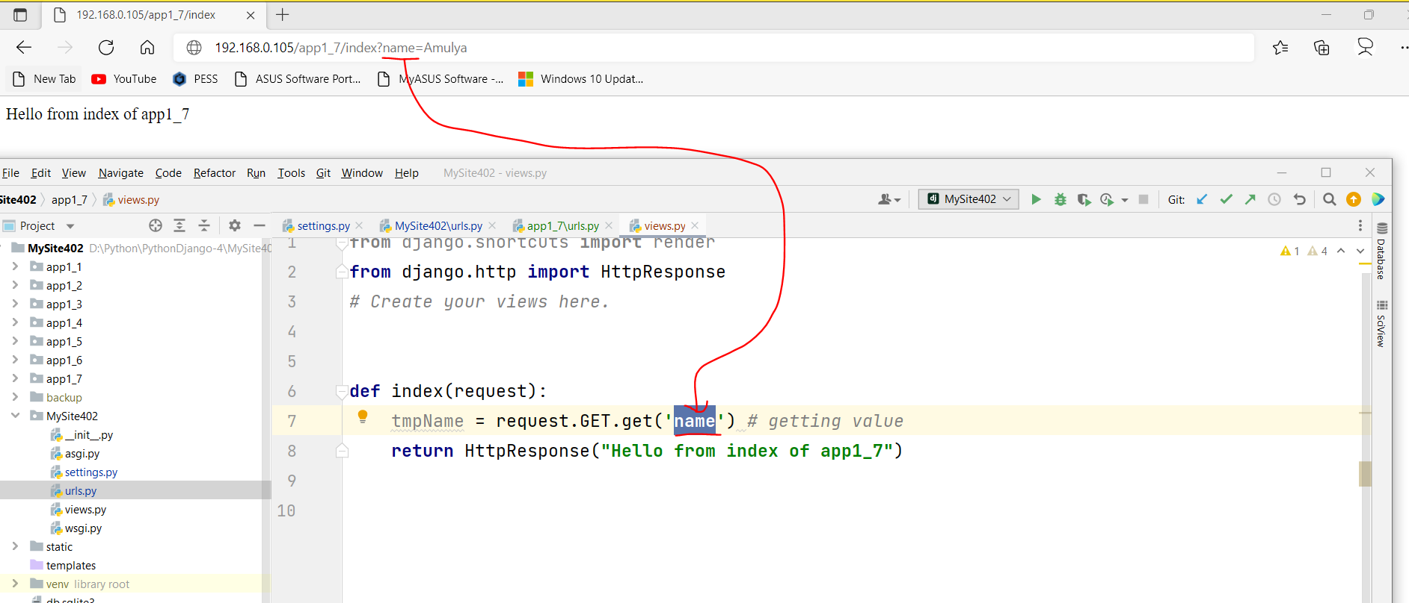

* **Redirect value to Terminal and Browser**

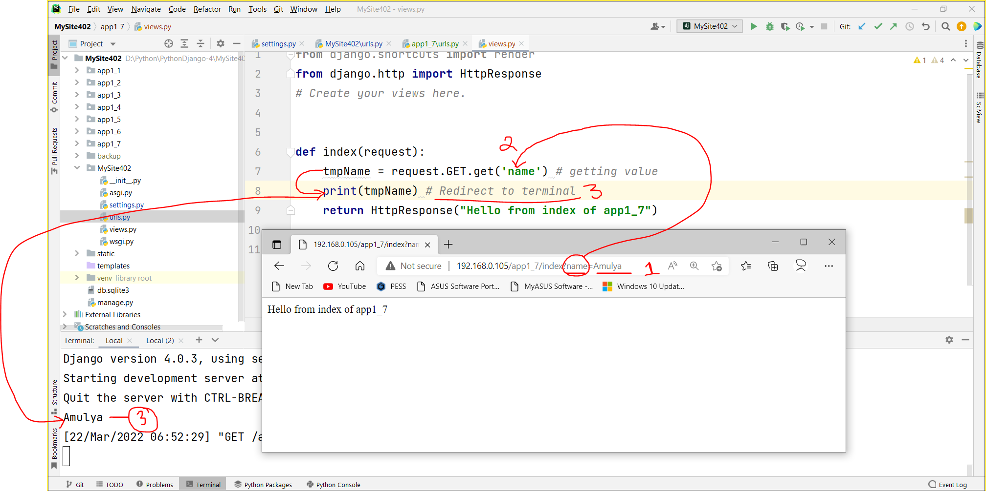

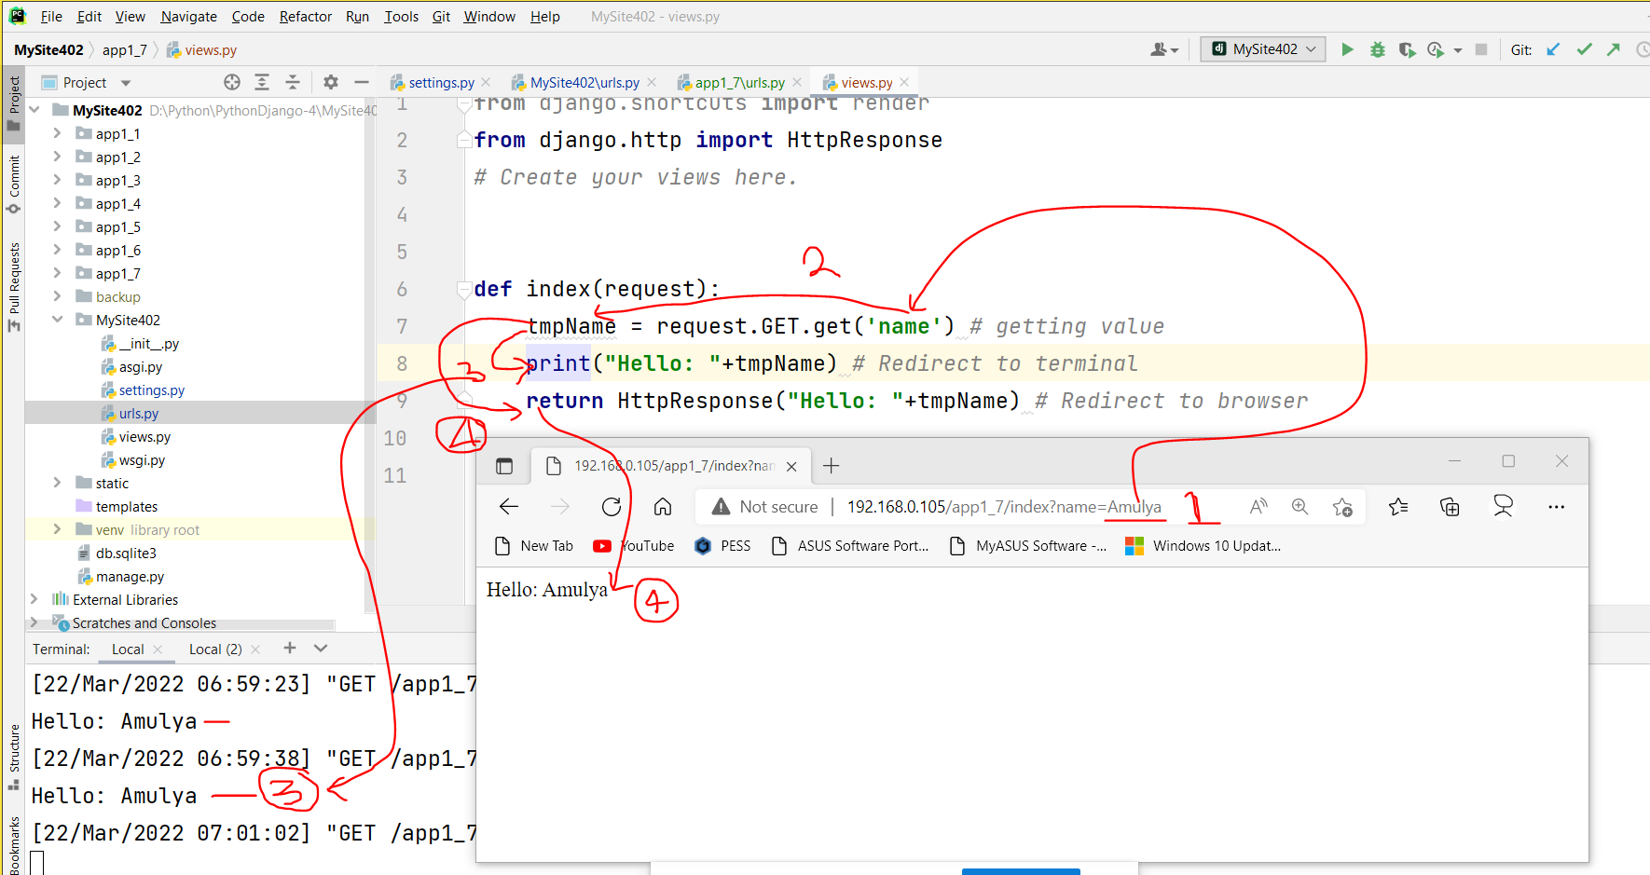

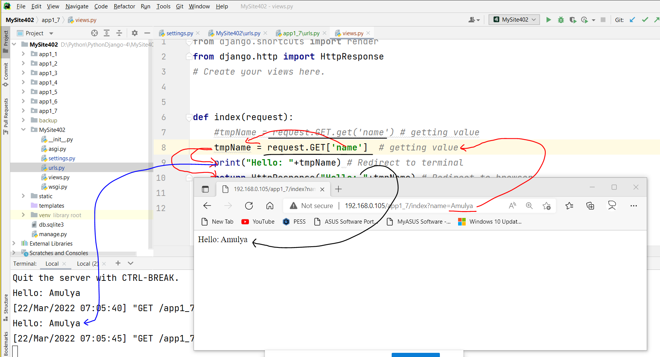

* **Redirect to template (html file)**
  + Create template file (html file [app1_7\templates\app1_7\index.html])
  + Render template (html file)
  + Sending value to tmplate

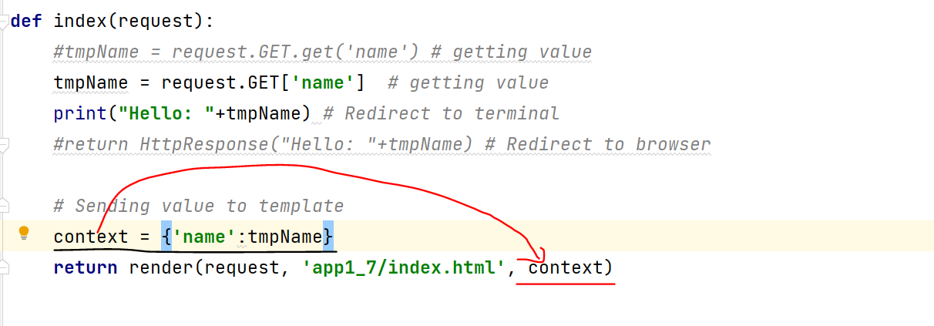

* + Display **value** on **template (html file)**

